Tier 1 Private Schools- Strong Music & Athletics
School | Location | Enrollment | Construction / Project Activity
Harvard-Westlake School | 3700 Coldwater Canyon Ave / 700 N Faring Rd. Studio City / Beverly Hills | ~1,600 (est.) | Major project underway: New 17-acre River Park athletic campus; completion targeted Fall 2026
Brentwood School-East Campus 6-12 | 100 S Barrington Pl., West Los Angeles | ~1,200 | Long-term master plan: Phased expansion through 2040
Loyola High School | 1901 Venice Blvd Los Angeles | ~1,200 (est.) | Recent + ongoing upgrades: science hall, academic center, master planning
Flintridge Preparatory School | 4543 Crown Ave  La Cañada Flintridge, CA | ~530 | Continuous upgrades: STEAM building + campus renovations
Sierra Canyon School | 20801 Rinaldi St. Chatsworth, CA | ~1,100 | Recent + ongoing: arts center + athletics expansion
Crossroads School | 1714 21st St., Santa Monica | ~1,200 | Active construction: 55,000 SF Performing Arts Center (~2026)
Windward School | 11350 Palms Blvd. West Los Angeles | ~625 | Master plan: campus rebuild + performing arts expansion
Campbell Hall School | 4533 Laurel Canyon Blvd. Studio City / North Hollywood | ~1,100 | No major recent projects identified
Viewpoint School | 23620 Mulholland Hwy. Calabasas | ~1,200 | No major current projects identified
The Webb Schools | 1175 W Base Line Rd. Claremont | ~405 | No major active expansion noted
Oaks Christian School | 31749 La Tienda Dr., Westlake Village | ~1,500 (est.) | Active expansion: New TK–3 campus opening 2026
Marymount High School | 10643 Sunset Blvd., Los Angeles | ~310 | Facility upgrades: science labs + arts renovations
Core Independent / College Prep
School | Location | Enrollment | Construction / Project Activity
Westridge School | 324 Madeline Dr.  Pasadena, CA | ~550 | Ongoing campus improvements: multi-phase expansion incl. science center + campus growth plan
Archer School for Girls | 11725 Sunset Blvd, Brentwood (Los Angeles, CA) | ~500 | Major master plan: “Archer Forward” (academic, athletics, arts expansion)
Oakwood School | 11600 Magnolia Blvd (Secondary) / 11230 Moorpark St (Elementary) North Hollywood / Studio City, CA | ~800 (est.) | Incremental upgrades: phased campus improvements
Wildwood School | 11811 Olympic Blvd (Secondary)/  12201 Washington Pl (Elementary)  West Los Angeles, CA | ~700 | Recently modernized campus: no major active construction
New Roads School | 3131 Olympic Blvd.  Santa Monica, CA | ~550 | Stable campus: no major current build; prior improvements completed
Pilgrim School | 540 S Commonwealth  Ave,  Los Angeles, CA | ~328 | No major capital projects identified: program-focused investment
Rolling Hills Prep | 1 Rolling Hills Prep Way San Pedro, CA | ~225 | No major construction: stable campus footprint
Sequoyah School | 535 S Pasadena Ave  Pasadena, CA | ~350 (est.) | Limited visibility: no significant current projects identified
Catholic / Faith-Based
School | Location | Enrollment | Construction / Project Activity
St. John Bosco HS | 13640 Bellflower Blvd  Bellflower, CA | ~1,000 (est.) | Ongoing strategic upgrades: long-term campus modernization
Notre Dame HS (Sherman Oaks) | 13645 Riverside Dr  Sherman Oaks, CA | ~1,200 | Active expansion: athletics, aquatics, parking; future dining commons
Bishop Montgomery HS | 5430 Torrance Blvd  Torrance, CA | ~850–900 | Recent investment: STEAM labs + athletics upgrades
Alemany HS | 11111 N Alemany Dr  Mission Hills, CA | ~1,300 (est.) | Incremental upgrades: ongoing campus improvements
Chaminade College Prep | 7500 Chaminade Ave  West Hills, CA | ~1,360 | Major expansion underway: classroom building, athletics, aquatic center
Louisville HS | 22300 Mulholland Dr  Woodland Hills, CA | ~290 | Recent upgrades: innovation lab + campus improvements
Fairmont Prep | 2200 W Sequoia Ave  Anaheim, CA | ~650 | Stable campus: no major current build
Cathedral High School | 1253 Bishops Rd  Los Angeles, CA | ~800 (est.) | Major project completed: performing arts complex
Mayfield Senior School | 500 Bellefontaine St.  Pasadena, CA | ~330 | Campus improvements: master plan + renovations
St. Francis HS | 200 Foothill Blvd  La Cañada Flintridge, CA | ~900 (est.) | Ongoing reinvestment: no major current project
La Salle College Prep | 3880 E Sierra Madre Blvd  Pasadena, CA | ~600 | Long-term master plan: athletics, arts, classroom expansion
Expanded Independent + Regional Private Schools
School | Location | Enrollment | Construction / Project Activity
Providence High School | 511 S Buena Vista St.  Burbank, CA | ~400 (est.) | No major capital projects identified: stable campus environment
EF Academy Pasadena | 1539 E Howard St.  Pasadena, CA | ~300 (est.) | Newer purpose-built campus: modern facilities with recent development
Southwestern Academy | 2800 Monterey Rd  San Marino, CA | ~200 (est.) | No major construction activity: stable campus footprint
Amerigo LA (Bishop Montgomery campus) | 5430 Torrance Blvd  Torrance, CA | Included within BMHS | Shared campus: utilizes Bishop Montgomery facilities (no separate build)
The Thacher School | 5025 Thacher Rd  Ojai, CA | ~260 (est.) | Ongoing campus upgrades: typical boarding school reinvestment
Idyllwild Arts Academy | 52500 Temecula Rd  Idyllwild, CA | ~300 (est.) | Continuous arts investment: studios + performance facilities
Fusion Academy (network) | Multiple addresses Los Angeles area | Small campus model | No traditional builds: micro-campus / leased spaces
Echo Horizon School | 3430 McManus Ave  Culver City, CA | ~300 (est.) | Recently modernized campus: no major active expansion
Turning Point School | 14618 Sylvan St  Culver City, CA | ~300 (est.) | No major public projects identified: incremental improvements only
Foothill Country Day School | 1035 W Harrison Ave  Claremont, CA | ~350 (est.) | Stable campus: no major current construction activity
Le Lycée Français de LA | 3261 Overland Ave (main campus)  Los Angeles, CA | ~1,000+ (est.) | Distributed campuses: periodic upgrades across locations
Immaculate Heart HS | 5515 Franklin Ave  Los Angeles, CA | ~700 (est.) | No major active construction identified: steady reinvestment
Windward Middle / associated programs | 11350 Palms Blvd  Los Angeles, CA | Included w/ Windward School | Part of larger campus: tied to Windward expansion + arts investment
Berkeley Hall School | 15700 Mulholland Dr  Los Angeles, CA | ~300 (est.) | Campus modernization completed: no major new projects active
Brentwood Lower Campus programs | 100 S Barrington Pl  Los Angeles, CA | Included w/ Brentwood School | Part of master plan: long-term Brentwood expansion
Oak Park Independent / regional feeders | 5801 Conifer St  Oak Park, CA | ~2,000+ (district) | Ongoing public capital improvements: projects vary annually

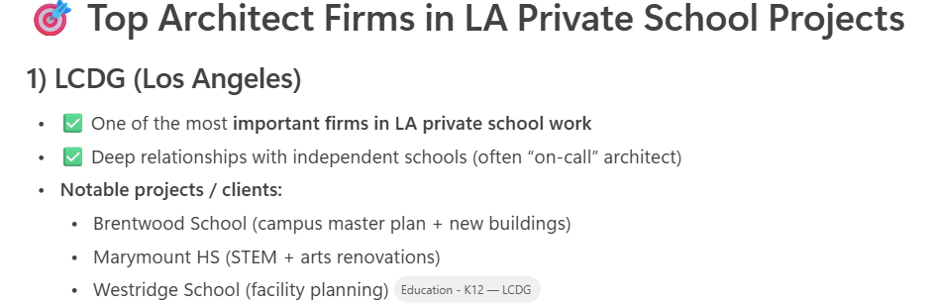
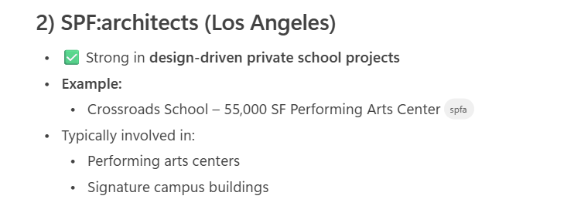
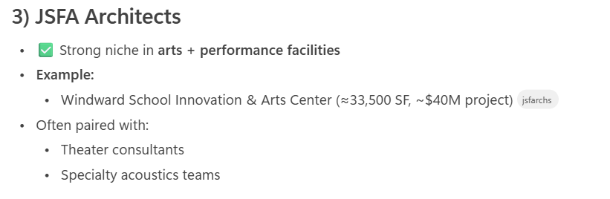
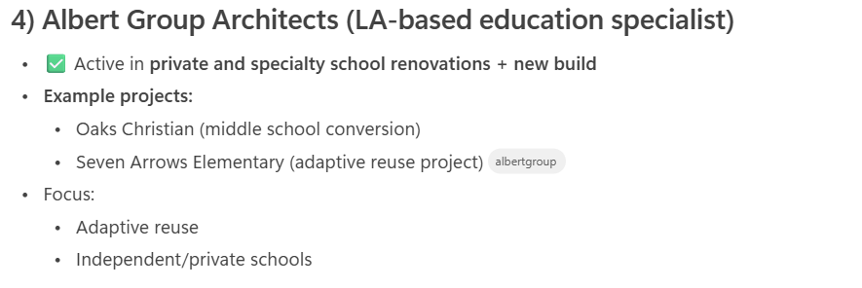
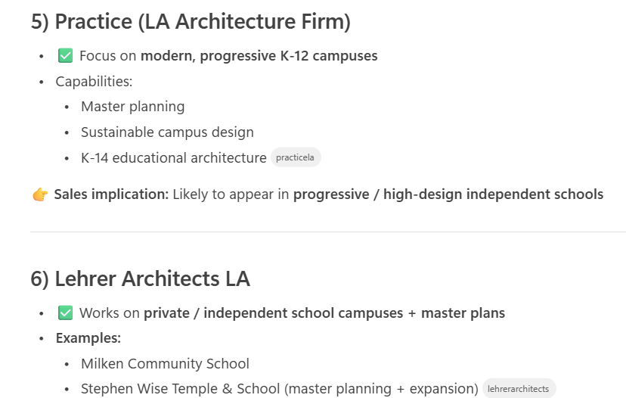
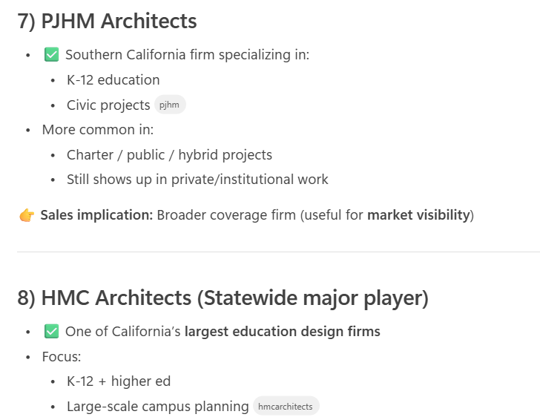
Architects: Key to Prop 28/LA USD
- CO Architects – auditoriums, performance spaces, large modernization projects
[coarchitects.com]
- Eaton Hall Architecture – high schools, academies, modernization
[eatonhalla...ecture.com]
- Berliner Architects – charter and modular / scalable academic buildings
[berliner-a...itects.com]

